Configure laptop so it does not suspend when lid is closed

Backup existing file
$ sudo cp /etc/systemd/logind.conf /etc/systemd/logind.conf.back

Open file for editing
$ sudo nano /etc/systemd/logind.conf

We want to change “#HandleLidSwitch=suspend” to “HandleLidSwitch=ignore”

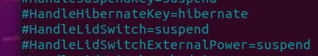

ctrl+O and ctrl-X to write the updated lines and exit

Restart service
$ systemctl restart systemd-logind.service

From remote machine VNC into the Tractor
Open Visual Studio and confirm the TTGO board is sending data to the serial monitor.
Close the lid and from the remote machine make sure the serial data continues

If the above does not work, you may have to install these tools:

sudo apt install pm-utils

https://itsfoss.com/ubuntu-close-lid-suspend/#:~:text=Go%20to%20System%20Settings%20and,Ubuntu%20by%20closing%20the%20lid.

